**Hybrid Pneumonia Detection using Chest X-Ray Images in Python**

1. ***Background/ Problem Statement***

Every year, a large number of children worldwide die from pneumonia. In 2016, an estimated 1.2 million cases of pneumonia in children under the age of five were recorded, with 880,000 deaths.

Pneumonia is a respiratory infection caused by bacteria or viruses that affects many people, particularly in poor and underdeveloped countries with high levels of pollution, unsanitary living conditions, overcrowding, as well as inadequate medical infrastructure.

A chest X-ray test is a frequent and inexpensive diagnostic imaging method. Clinical diagnosis of the lung or chest X-ray might be in great demand. However, it is sometimes more difficult than lung diagnosis by computed tomography imaging for the chest.

Our Hybrid Pneumonia Detection System is developed for detecting lung diseases from X-ray images.

1. ***Working of the Project***

# Early detection of pneumonia is critical for curative therapy and increasing survival rates. The most often used approach for detecting pneumonia is chest X-ray imaging. However, examining chest X-rays is a difficult process that is vulnerable to subjective variability.

# Here, for the hybrid model, DNN will be used with the Ada Boost classifier and for the dataset chest, x-ray images will be used.

The front-end involves Html, CSS, and JavaScript and the back-end involves Python. The framework used is Django and the database is MySQL.

1. ***Advantages***

* It’s easy to maintain.
* It’s user-friendly.
* Pneumonia is detected instantly from chest x-ray images.

1. ***System Description***

The system comprises 1 major module with their sub-modules as follows:

**USER**

* **Registration**

Name, Age, Gender, Address, Phone number, Email ID)

* **Login**
* **Detect**

Uploading the image and result will be displayed as normal or pneumonia)

* **Logout**

1. ***Project Life Cycle***

The waterfall model is a classical model used in the system development life cycle to create a system with a linear and sequential approach. It is termed a waterfall because the model develops systematically from one phase to another in a downward fashion. The waterfall approach does not define the process to go back to the previous phase to handle changes in requirements. The waterfall approach is the earliest approach that was used for software development.

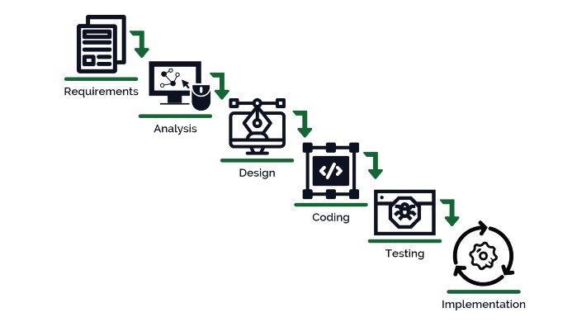

1. ***System Requirements***
2. ***Hardware Requirement***
3. **Laptop or PC**

* Windows 7 or higher
* I3 processor system or higher
* 4 GB RAM or higher
* 100 GB ROM or higher

1. ***Software Requirement***
2. **Laptop or PC**

* Python
* Sublime text Editor
* XAMP Server

1. ***Limitation/Disadvantages***

* The uploaded image must be correct.

1. ***Application*** – This application was developed to identify lung diseases in X-ray pictures.
2. ***Reference***

* [*https://www.researchgate.net/publication/342619947_Pneumonia_Detection_in_chest_X-ray_images_using_Convolutional_Neural_Networks_and_Transfer_Learning*](https://www.researchgate.net/publication/342619947_Pneumonia_Detection_in_chest_X-ray_images_using_Convolutional_Neural_Networks_and_Transfer_Learning)
* [*https://www.researchgate.net/publication/354432343_Pneumonia_detection_in_chest_X-ray_images_using_an_ensemble_of_deep_learning_models*](https://www.researchgate.net/publication/354432343_Pneumonia_detection_in_chest_X-ray_images_using_an_ensemble_of_deep_learning_models)
* [*https://www.ncbi.nlm.nih.gov/pmc/articles/PMC7345724/*](https://www.ncbi.nlm.nih.gov/pmc/articles/PMC7345724/)
* *https://www.sciencedirect.com/science/article/pii/S2352914820300290*